MARYS MEALS
Presented by: Sue Donovan
Talk: Friday March 13th at 2pm
The Civic Suite
We have Sue, one of the many fabulous volunteers from Marys Meals, coming to talk to us about the wonderful work that this charity does in some of the poorest communities around the world.
It’s not just about the charity but it’s helping us to understand how children across the world are exposed to a very different way of life compared to the life our children have. The charity serves more than 3 million children every school day, providing life changing school meals along with other support, encouraging to attend school etc.
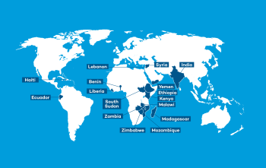
Come and find out more about how they do this amazing work.
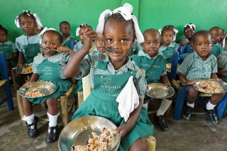
Members: £5 Non-members £8
Includes refreshments

