 Sunday Lunch Club No 4

The first of our Sunday lunches this year is taking place on 29th March at the 3 Stags Pub, Bebington. Everyone is welcome whether you’re on your own, with a partner, friend or neighbour. Forget the cooking and the washing up and have a few hours of good food and good company.

Where: 3 Stags pub, Church Road, Bebington. CH63 3EA
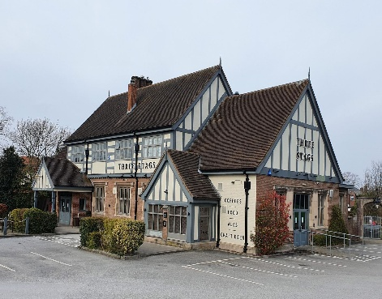
When: Sunday 29th March 2026 Time: 1.30pm
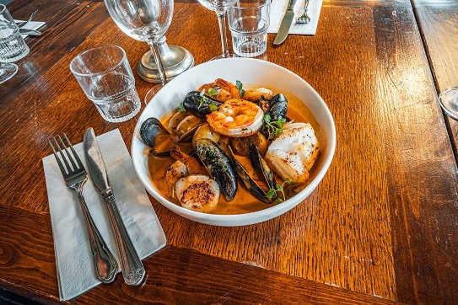

Please book via the Wirral 3Ls office, Bebington Civic Centre

Sundays can be quite busy so book early. There’s a great menu choice, including vegan and vegetarian options.

(Table booked in the name of Adele)

